**Timekeepers and Coaches**



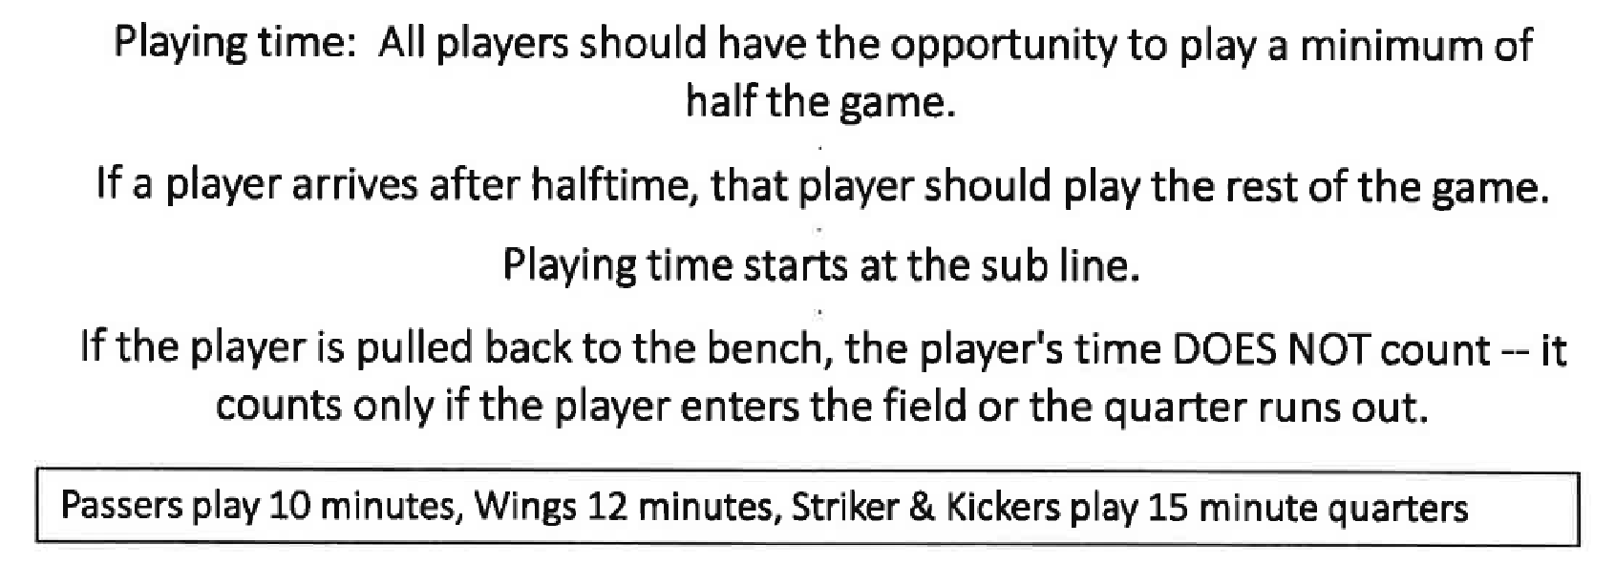

For each game, the head coach of each team shall select a parent from their team who is NOT a Coach to act as Field Supervisor/Timekeeper.

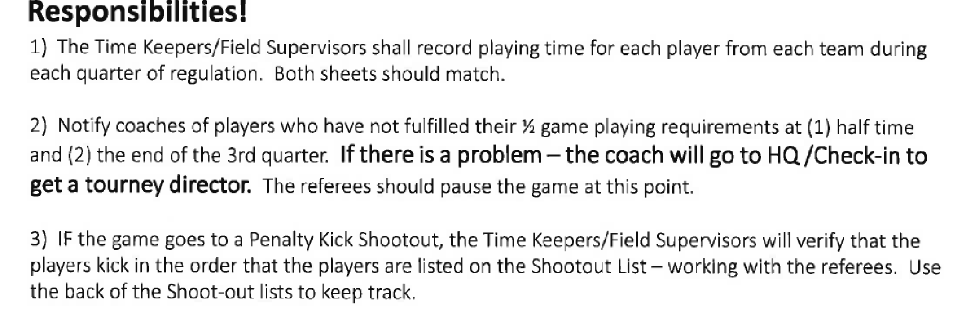

ROSTER FORMAT

(1) Team Rosters can be submitted in the format that is in use within your Area.

(2) However, regardless of its format, the Roster

(A) MUST contain information that is identical to that on file with your League, SAY Area, and SAY

(B) MUST contain at least the following information:

i. The Players: Last and First Names, Date of Birth, Home address, Telephone number, and Shirt number

ii. The Coaches: Last and First Names

iii. A clear identification of the SAY Area, SAY District, Playing Division, the Team's Name, and (optionally) the team’s sponsor (if any).

(C) MUST identify your SAY Area President (INCLUDING those Team Rosters that are computer generated).

(3) Regardless of their format

(A) Rosters submitted by the Area President need not be signed

(B) Rosters submitted by anyone other than the Area President MUST be signed; and the name of the SAY Area’s President and his/her signature MUST appear somewhere on the roster as verification that the team is the Area's representative.